Exercise 1

Repository Setup
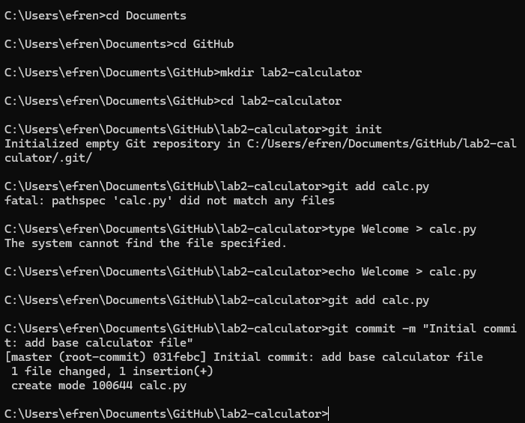

Feature Branch Creation
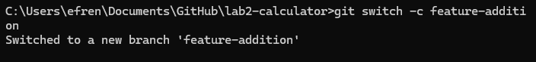

Atomic Commits
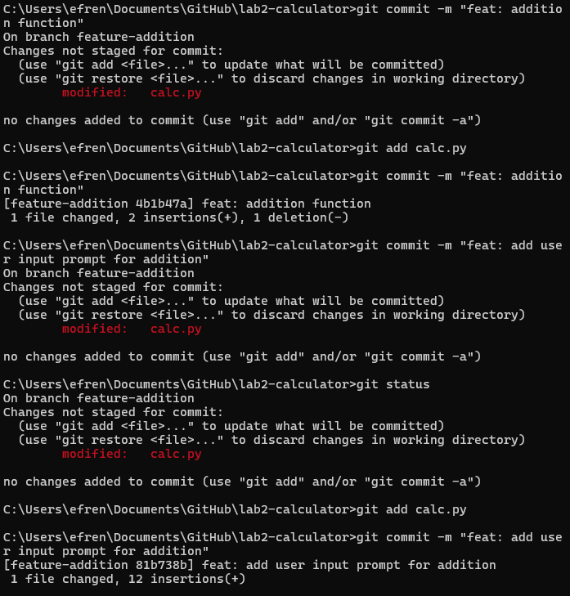

Merging Locally
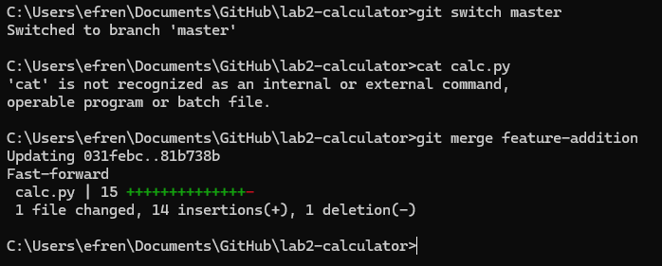

Thinking question
If you did a mistake at the very and didn’t do small commits throughout your day, it would erase all progress and you will have to do everything all over again

Exercise 2

Pushing to GitHub
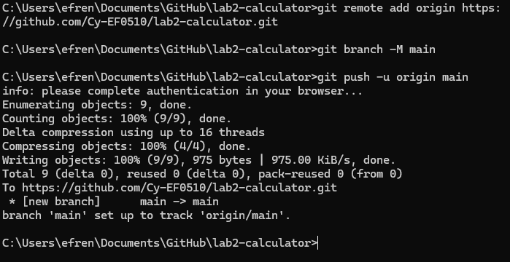

Creating an Issue
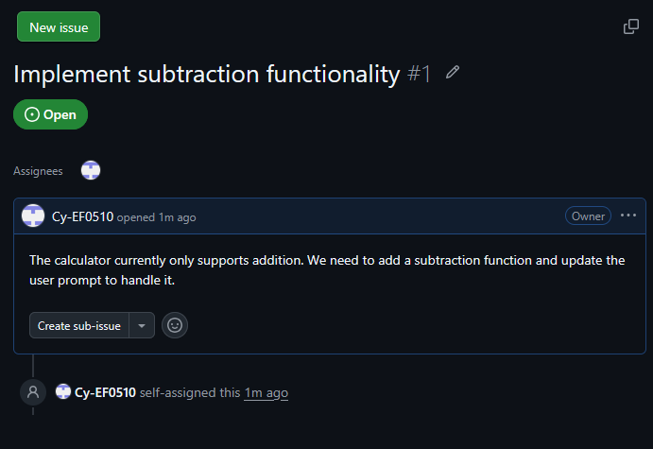

Setting up a Project Board
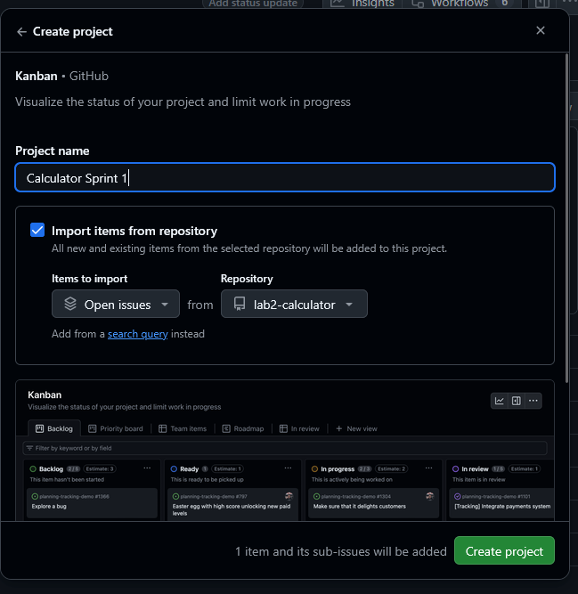
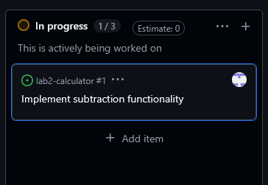

Thinking Question
They act as the single source of information so that there is no confusion or duplicate. They provide immediate visual accountability and enforce workflow boundaries so no two developers will work on the same issue unless told otherwise

Exercise 3

Develop the Feature
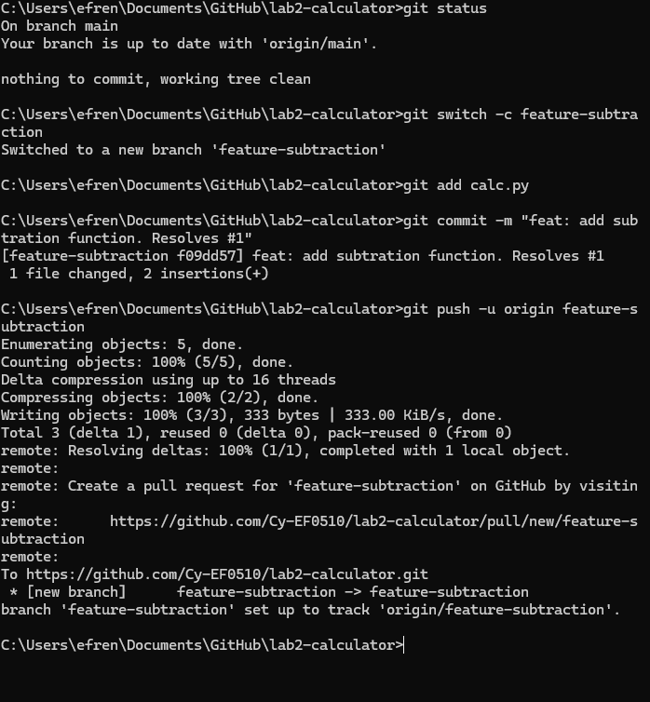

Open the Pull Request
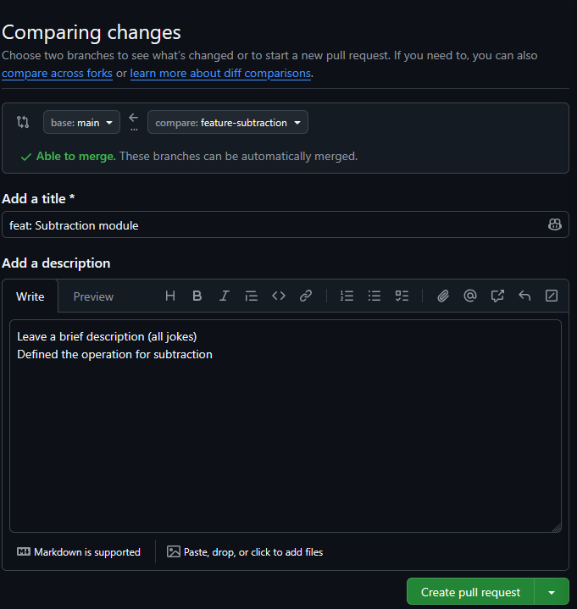
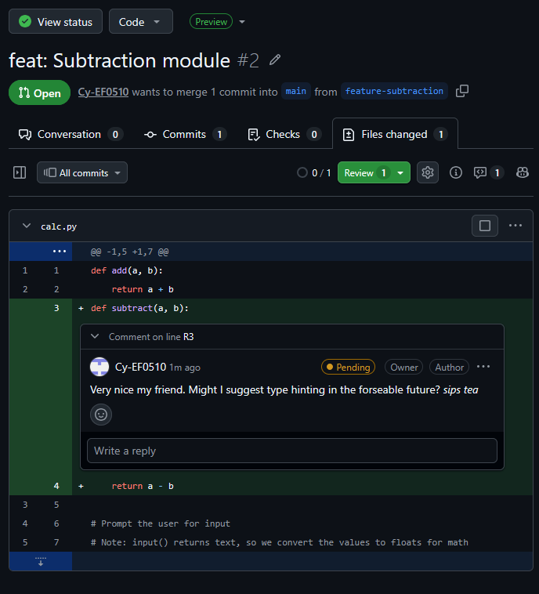
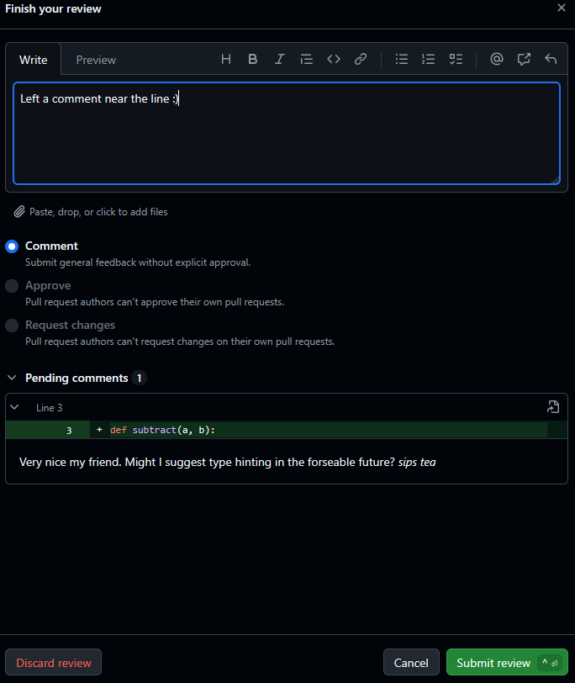

Conduct a Code Review
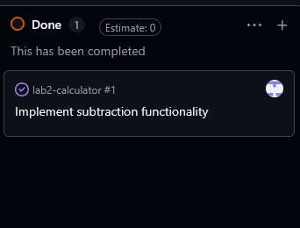

Merge and Automatic
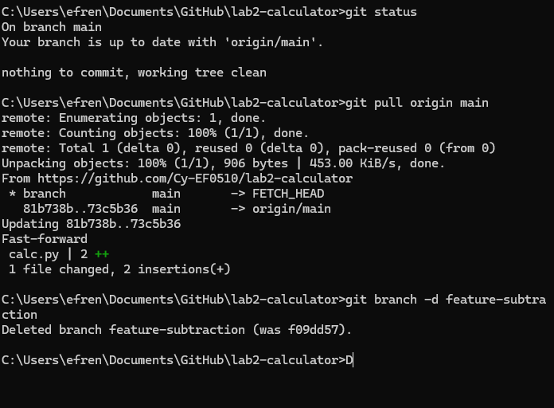

Thinking Question
We used a simple ”Merge Pull Request”. What is the difference between merging a PR
and ”Squash and Merge”? Why might a team prefer ”Squash and Merge” for a PR that
has 30 small ”wip” (work in progress) commits?

The difference between PR and Squash and Merge is that PR saves all commits that you’ve done, whereas SM would combine all your commits into on big commit. A team may prefer SM as it can make the main history clean, simplify code debugging and you can revert easily as it is linear unlike PR (non-linear)

